Name: **ZOHAIB HASSAN SOOMRO**

RollNo#: **19SW42**

Subject: **Computer Networking**



1. Which cable did you use to connect workstations in Task 3?

Ans: A **Cross-Over** cable. i.e that is used to connect two same devices.

1. What was the output of **ping** command in Step 3 of Task 3? What happens if you unplug the network cable and ping the other workstation?

Ans:

**Connection:**

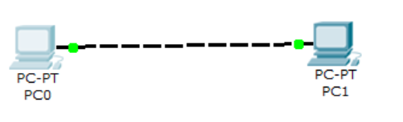

**Output of Ping Command:**

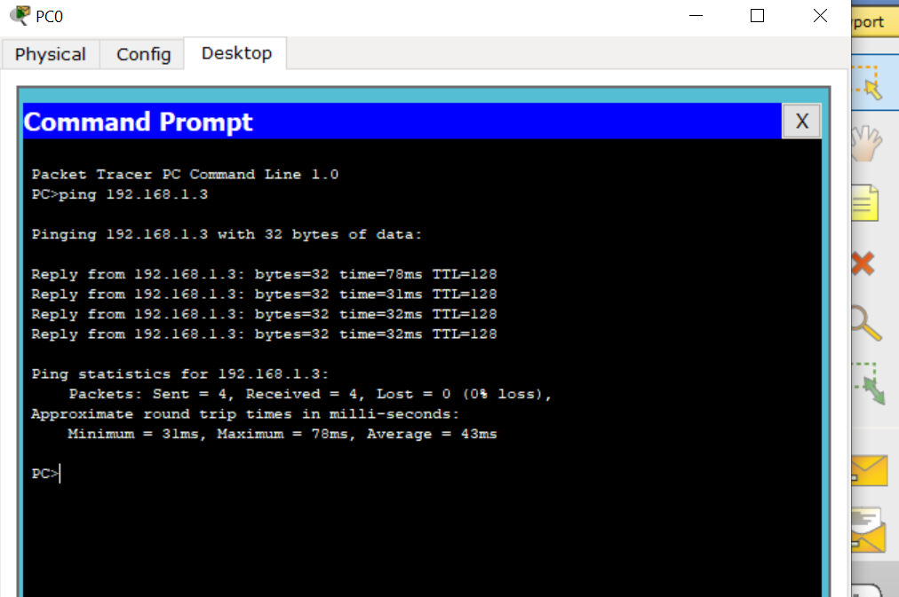

b. if we unplug and then ping:

Connection:

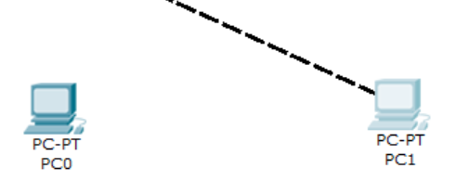

Ping Output: i.e Request Timed out message.

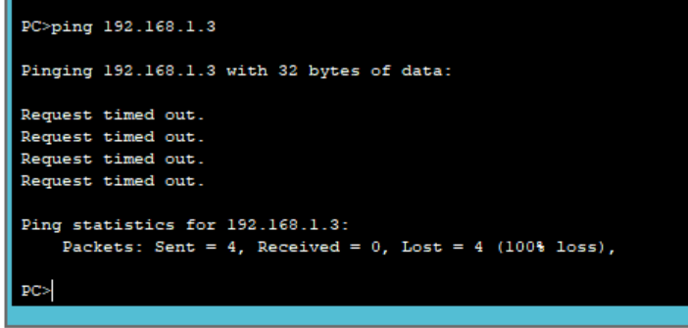

1. What was the output of **ping** command in Task 4? What happens if you ping an address that is not connected to the network?

Ans:

**Connection:**

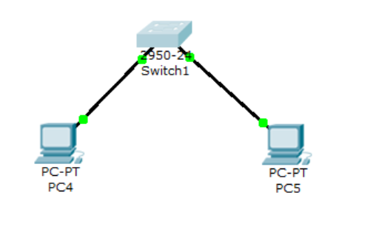

**Ping Output:**

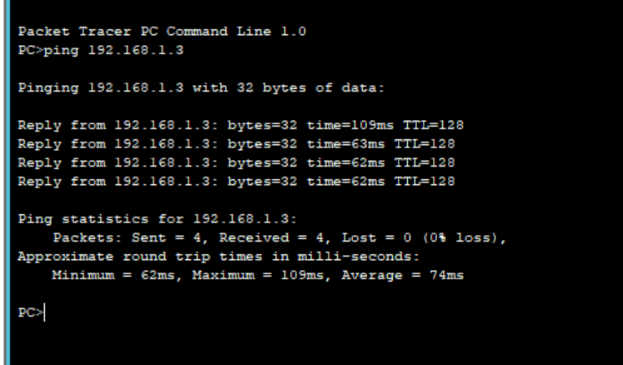

**Ping Output when a pc with certain ip is not over the network:**

**Connection:**

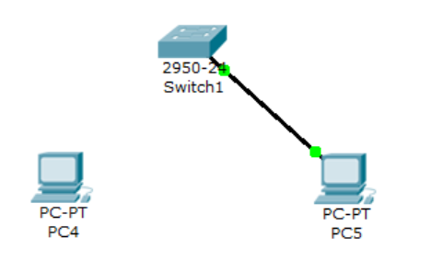

Here the **PC4(192.168.1.2)** is not over the network so pinging it from **PC5’s command prompt** will result in:

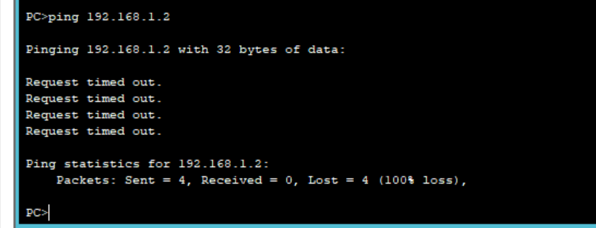

i.e **Request will be timed out.**

1. What could prevent a ping from being sent between the workstations when they are directly connected?

Ans: Using straight-over cable or assigning wrong ip-address to any of the workstations can prevent a ping from being sent between the workstations when they have a direct connection.

1. What could prevent the ping from being sent to the workstations when they are connected through the switch?

Ans: There can be more than one reason that can prevent the ping being sent to the workstations when they are connected through a switch, few of them are given below:

Connecting workstations to switch with cross-over cable

Switch may be turned off.

Switch can be faulty.

Port may be faulty.

Assigned wrong ip-addresses to the workstations.

Firewall might be turned on.